# How to achieve a localization web application in ASP.NET Core

## Introduction

This sample will demonstrators how to set localization of your web site in ASP.NET Core.

## Sample prerequisites

.NET Core 1.0 or later version(s). [[.NET Core + Visual Studio tooling](http://go.microsoft.com/fwlink/?LinkID=798306)]

Microsoft Visual Studio 2015 update3 or above. [[Visual Studio 2015](https://www.visualstudio.com/)]

## Building the sample

* Open the sample solution “**CSLocalizationASPNETCore.sln**” using Visual Studio.
* Right click on the project “**CSLocalizationASPNETCore**” and select Restore packages.

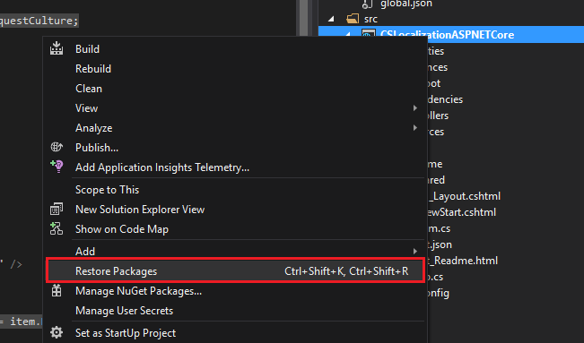

* Press **F6 Key** or select **Build -> Build Solution** from the menu to build the sample.

## Running the sample

* Open the Sample solution using Visual Studio, then press **F5 Key** or select **Debug -> Start Debugging** from the menu.
* When the web application is running, you can see the page in browser.

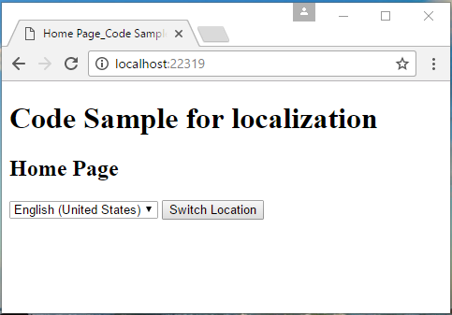

* Choose a language at **dropdown list**, and click **Switch Location** button.

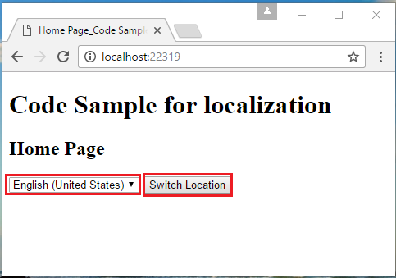

* The language will be updated with your choice.

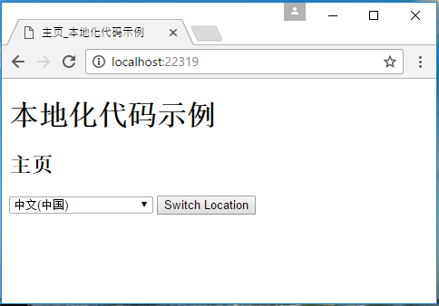

## Using the code

The Resource and Views like:

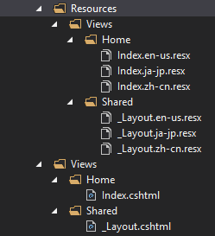

**In Startup.cs**

public void ConfigureServices(IServiceCollection services)

{

services.AddLocalization(opts => { opts.ResourcesPath = "Resources"; });

services.AddMvc()

.AddViewLocalization(

Microsoft.AspNetCore.Mvc.Razor.LanguageViewLocationExpanderFormat.SubFolder,

opts => { opts.ResourcesPath = "Resources"; }

)

.AddDataAnnotationsLocalization();

services.Configure<RequestLocalizationOptions>(opts =>

{

var supportedCultures = new[]

{

new CultureInfo("en-US"),

new CultureInfo("ja-JP"),

new CultureInfo("zh-CN")

};

opts.DefaultRequestCulture = new Microsoft.AspNetCore.Localization.RequestCulture("en-US");

opts.SupportedCultures = supportedCultures;

opts.SupportedUICultures = supportedCultures;

});

}

// This method gets called by the runtime. Use this method to configure the HTTP request pipeline.

public void Configure(IApplicationBuilder app, IHostingEnvironment env, ILoggerFactory loggerFactory)

{

app.UseRequestLocalization();

app.UseMvc(routes =>

{

routes.MapRoute(name: "default", template: "{controller=Home}/{action=Index}");

});

}

**In HomeController.cs**

public class HomeController : Controller

{

//you can use the localizer in you controller

private readonly IStringLocalizer<HomeController> _localizer;

public HomeController(IStringLocalizer<HomeController> localizer)

{

_localizer = localizer;

}

public IActionResult Index()

{

return View();

}

public IActionResult SetLanguage(string culture, string returnUrl)

{

Response.Cookies.Append(

CookieRequestCultureProvider.DefaultCookieName,

CookieRequestCultureProvider.MakeCookieValue(new RequestCulture(culture)),

new CookieOptions { Expires = DateTimeOffset.UtcNow.AddYears(1) }

);

return LocalRedirect(returnUrl);

}

}

**_Layout.cshtml**

@using Microsoft.AspNetCore.Builder

@using Microsoft.AspNetCore.Localization

@using Microsoft.AspNetCore.Mvc.Localization

@using Microsoft.Extensions.Options

@inject IViewLocalizer Localizer

@inject IOptions<RequestLocalizationOptions> LocOptions

@{

var cultureItems = LocOptions.Value.SupportedUICultures.ToList();

var currentCulture = Context.Features.Get<IRequestCultureFeature>().RequestCulture;

var sampleTitle = Localizer["Code Sample for localization"];

}

<!DOCTYPE html>

<html>

<head>

<meta name="viewport" content="width=device-width" />

<title>@(ViewBag.Title)_@sampleTitle</title>

</head>

<body>

<h1>@sampleTitle</h1>

<div>

@RenderBody()

</div>

<form action="/Home/SetLanguage">

<input name="returnUrl" type="hidden" value="@Context.Request.Path" />

<select name="culture">

@foreach (var item in cultureItems)

{

<option value="@item.Name" @(currentCulture.Culture.Name == item.Name ? "selected" : "")>

@item.DisplayName

</option>

}

</select>

<button type="submit">Switch Location</button>

</form>

</body>

</html>

**Index.cshtml**

@using Microsoft.AspNetCore.Mvc.Localization

@inject IViewLocalizer LocOptions

@{

ViewData["Title"] = LocOptions["Home Page"];

}

<h2>@ViewData["Title"]</h2>

## More information

Globalization and localization

<https://docs.asp.net/en/latest/fundamentals/localization.html>